Participants’ “suitcases”
[What the workshop participants brought along to Graz, in their ‘suitcases’ (TrainEd central workshop 9/2004)]

Some questions: | Some expectations:
- Quelles sont les procédés didactiques les plus pertinents pour la formation des formateurs?  - Is it possible to know each other in such a large group?  - Will we all have the same “kit” needs?  - How have things changed with computer technology re: teacher training?  - Do we have common TT systems?  - How to cope with resistance to change?  - How to reconcile academic and hands on?  - Why kit – is it only procedures without theoretical background?  - Is there a universal set of materials to go into the kit?  - When does dissemination start?  - Will we ever get levels right across Europe? | - To discover new ways of organising TP course.  - Having fun.  - New ideas.  - Deeper understanding of process in other countries.  - Get to know some experts.  - Finding a ‘least common denominator’.  - To find support for my beliefs and understanding of T-T and perhaps update them.  - Become aware of training needs that I might have not noticed before.  - Hope to find I’m on the right track.
What I can offer: | Some worries, niggles:
- Willingness to cooperate.  - Input of creative ideas.  - ICT skills and expertise.  - Energy.  - Readiness to learn and work.  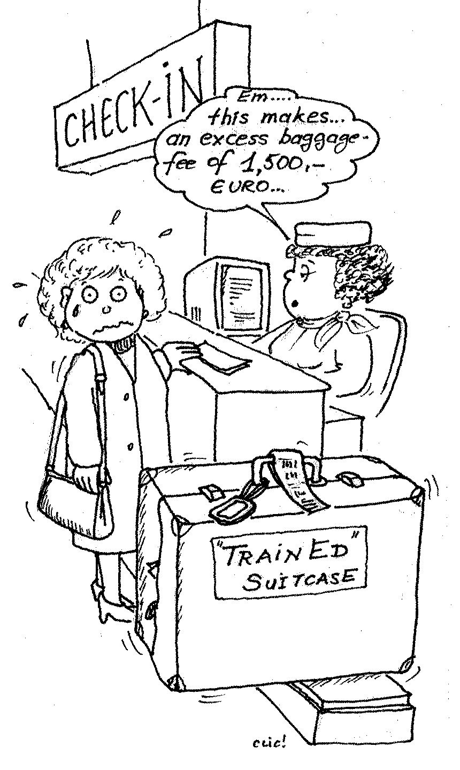  - Cheese. Dried meat. Chocolates.  - A bottle or two of fresh Styrian wine.  - Critical thinking strategies.  - Coaching of teachers.  - Portfolio. | - Aren’t we too large a group?  - How will it proceed with the 2 working languages?  - How to persuade authorities at home to innovate or change?  - I don’t feel I have much experience.  - Is a teaching background enough for learning how to train?  - Are ECML projects being put into practice?  - Are we going to practice something that can be appealing across many countries?  - What about the political and economic implications of what we’re doing?  - Will my neighbours have fed the cat?  - The faculty not being interested or understanding about TT.

