Types of training events
(Suggested by participants in the 2nd TrainEd central workshop)
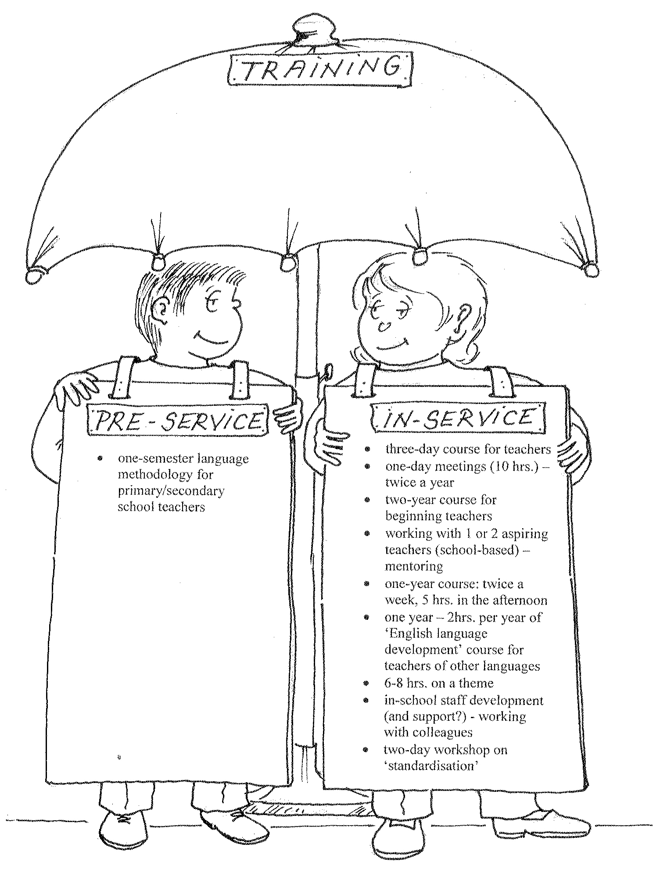
Other types of training events:  - courses (short or long)  - workshops (short or long)  - seminars  - conferences  - staff conferences  - video-conferencing  - work experience in classroom (observed teaching practice)  - mentoring meetings  - teachers’ meetings  - “mini-lessons”  - classroom research/projects  - round-table discussions | In which type of training events have you been involved:
 | - as a trainer?
 | - as a trainee?

